**Canmore Dog Parks**<https://canmore.ca/residents/off-leash-dog-parks>

* Outside of the off-leash area, dogs must be on leash
* Pick up your dog's poo
* Dogs must be licensed and vaccinations up to date
* Please keep your dog under control and within your sight
* Report dog bites to Bylaw Services at 403.678.4244

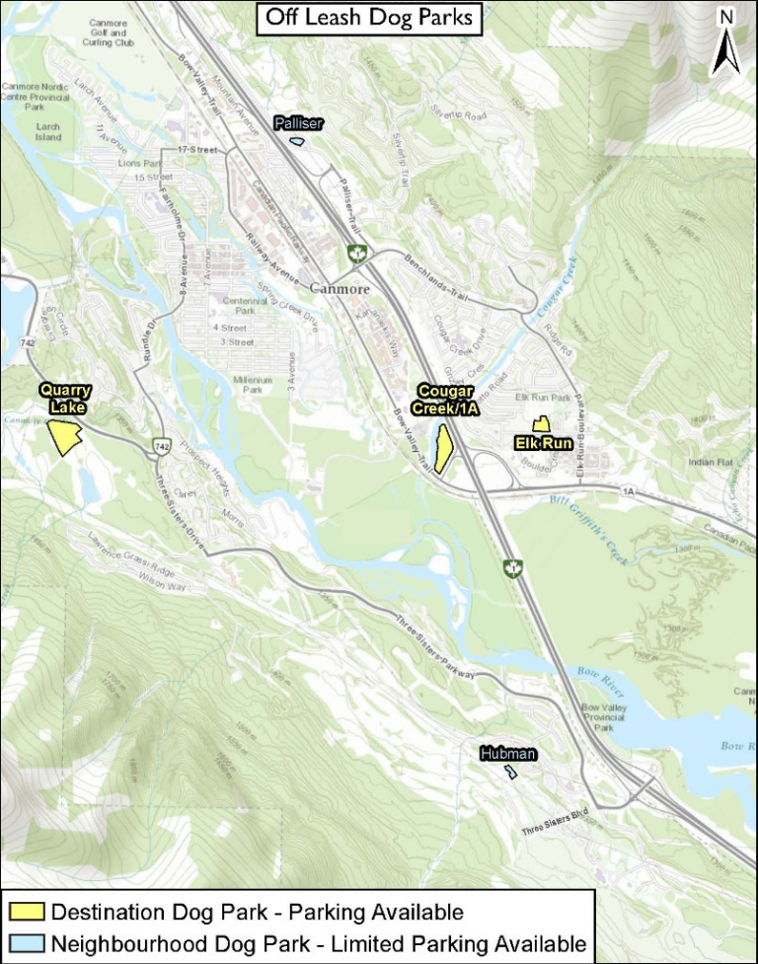

**Banff Dog Parks**

<http://banff.ca/index.aspx?NID=1030>

* Keep your dogs on a leash when entering and exiting the park.
* Make sure your dogs are wearing a valid licence.
* Keep your dog under voice and sight control at all times.
* Keep to a maximum of three dogs per guardian.
* Please don't bring aggressive or sick dogs, dogs in heat, and puppies under five months old.
* Children under 15 years old must be under adult supervision.
* Clean up after your dog and dispose of their waste in the nearby garbage bin.

